Interview with GERI SELENICA,
Executive Director of the Albanian Center of Strategic Studies,
published on 14.09.2015 at MONITOR magazines http://www.monitor.al/

OUR SUGGESTED PROJECTS TO THE ALBANIAN GOVERNMENT:

1 – “Qafë Thanë-Kapshticë Highway” was not in TEN-T Core Network!!

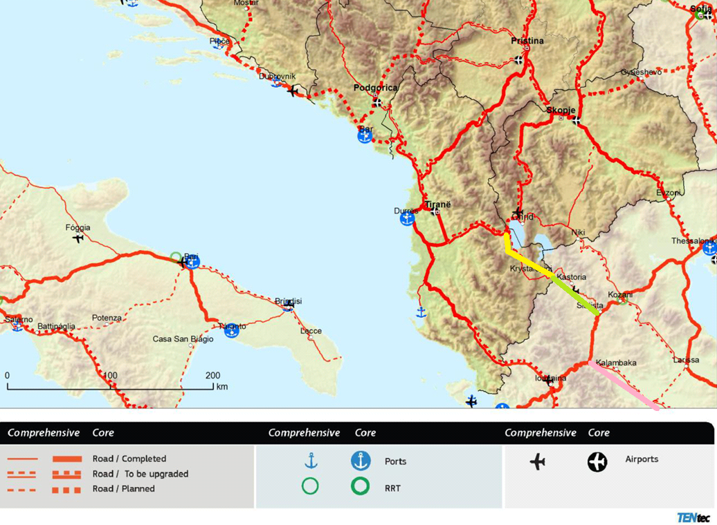

While Greek A2 EGNATIA has reached Kapshtica
(photo 13.9.2015)
Segment Koromilia (Kastoria) - Krystallopigi financed 139 milione € by EU

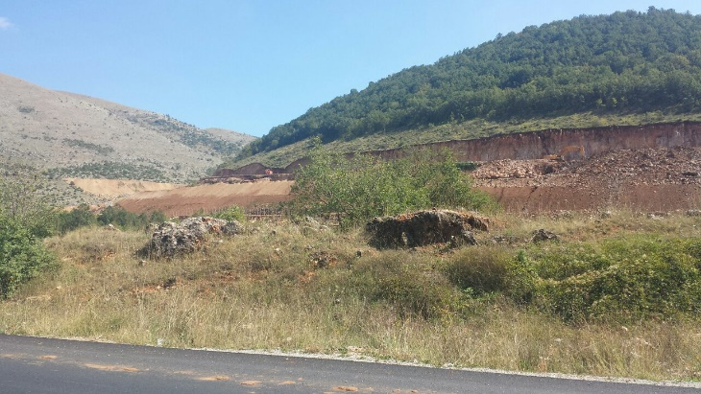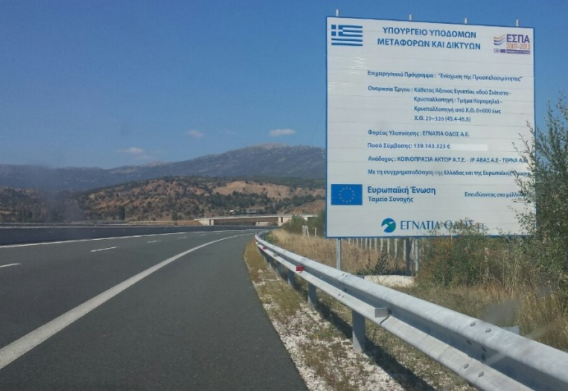
2 – “BLUE ADRIATIC AEGEAN RAILWAY”

Kalabaka-Kapshtica / missing completely
Florina-Kapshtica / is included in “TEN-T Core Network”
Kapshtica-Pogradec-Durrës-Tirana / NOT included in “TEN-T Core Network”
Tirana-Hani i Hotit-Podgorica / is included in “TEN-T Core Network”
Niksic-Čapljina-Ploče-Split / missing completely

